**TARGET**

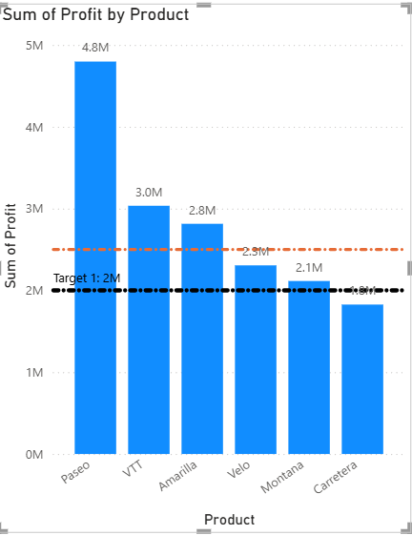

* **Steps:**
* **In Report View Tab**

1. Visualizations tab ->Build Visual
2. Click on **Clustered Column Chart**

* **Data Tab**

1. **Financials** -> Select Column name according to the given question.

* **Build Visual**

1. X-axis -> Product
2. Y-axis -> Sum of Profit, Sum of Sales

* **Format Visual**

1. Format Visual -> visual

* Legend -> ON
* Data Labels -> ON
* **Add further analyses to your visual**

1. **Y-axis Constant Line:**

* Add Line -> Target 1
* Line -> Value -> 2000000
* Color -> Black
* Transparency -> 0%.
* Width -> 5px
* Position -> in front

1. **Min Line:**

* Add Line -> Min Line 1
* Series -> Sum of sales

1. **Max Line:**

* Add Line -> Max Line 1
* Series -> Sum of sales

1. **Data Label (ON)** -> for Y-axis Constant Line, Min Line, Max Line

* Horizontal -> Left
* Vertical -> Above
* Style ->Both
* Color -> Blue
* Display Units -> millions

**DRILL DOWN & DRILL UP**

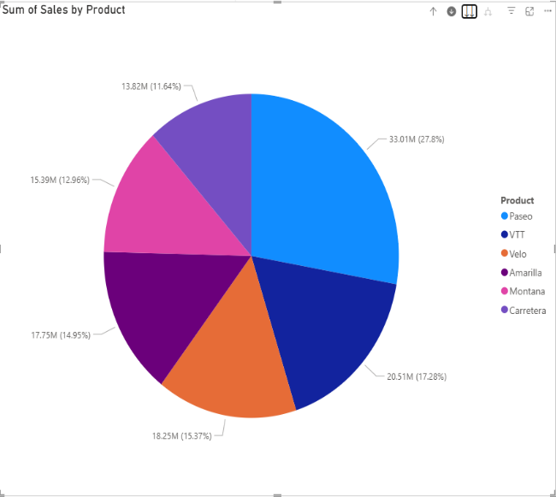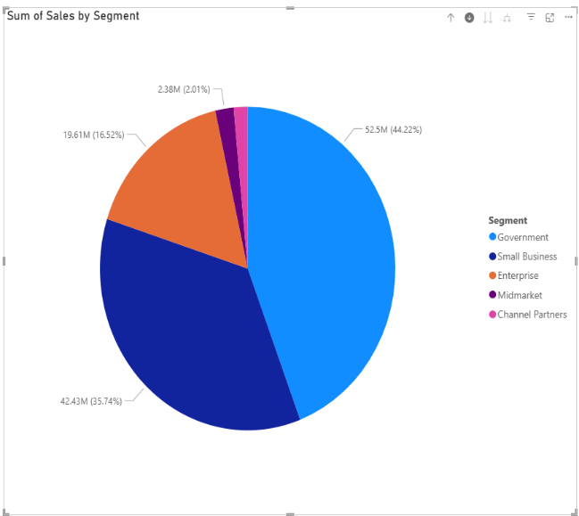

* **Steps:**
* **In Report View Tab**

1. Visualizations tab ->Build Visual
2. Click on **Pie Chart**

* **Data Tab**

1. **Financials** -> Select Column name according to the given question

* **Build Visual**

1. Legends -> Country, Discount band, Product, Segment
2. Values-> Sum of Sales

* **Format Visual**
* Legends -> ON
* Detail Label -> ON
* **For View Next Level**
* **↓ ->** Click to turn on **Drill Down**
* ** ->** Drill Mode is **ON**
* **↓** **↓ ->** Go to the next line in hierarchy
* **↑ -> Drill Up**

**SLICER**

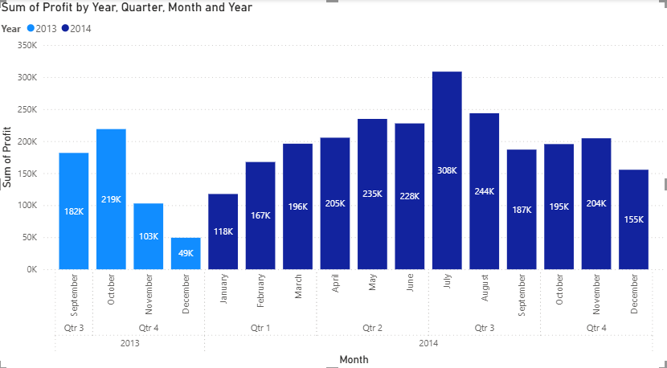

1. STEPS :

* IN REPORT ON VIEW TAB :
* Visualizations -> build visual
* Click on **stacked column chart**
* Data tab :
* Select column name according to the given question.

1). X – axis -> month, year

2). Y – axis -> Sum of profit

3). Legend -> year

* **Format Visual**
* Legends -> ON
* Data Label -> ON
* **To Add Slicer**

1. Visualizations tab ->Build Visual
2. Click on **Slicer**

* **Build Visual**

1. Field -> Country

* **Format Visual**

1. **Slicer Settings**

* Style -> Vertical List

1. **Selection**

* Multi-select with CTRL **(ON)**

1. **Slicer Header ->ON**

* Title text -> Country
* Font -> Arial
* Size ->12, Bold
* Font Color -> Blue..